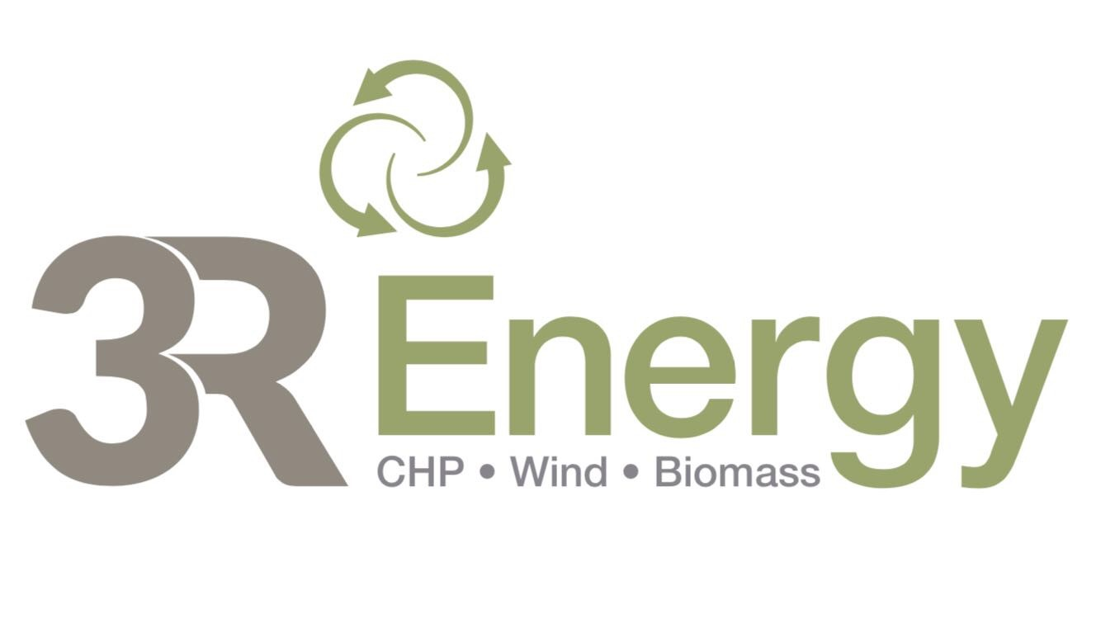
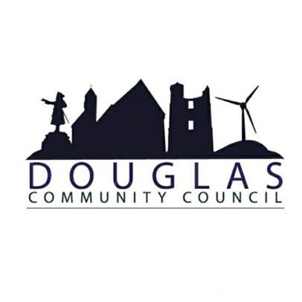

Hazelside & Ventient Galawhistle Micro-Grant Schemes administered by Douglas Community Council

Thank you for making an application to a Douglas Community Council Micro-Grants Scheme. Douglas Community Council administers Micro Grants on behalf of three Windfarm Community Benefit Funds:

• 3R Energy Hazelside (£2,500 pa)
• Ventient Galawhistle (£6,000 pa)
• South Lanarkshire Council Renewable Energy Fund (£5,000 pa)

This application form is for both the 3R Energy Hazelside and Ventient Galawhistle Funds only.

Prior to submitting any application, you are encouraged to email douglascommunitycouncil@gmail.com or call 07872 577515 to discuss your project and be advised which Fund it is most appropriate for you to apply to given fund demand and budgetary constraints.

You may apply for up to £250 as an individual or £500 as a community group, constituted or un-constituted.

The text boxes on this form will expand as you type but please note that some sections have character and word limits to encourage brevity.

Section 1: Your contact details
1.1 Name of group or individual applying.

1.2 Main Contact (if a group):
1.3 Telephone number (main):
1.4 Telephone number (alternative):
1.5 Email address:
1.6 Organisation Website and/or Facebook:
1.7 Address

Section 2: About your organisation
2.1 I am applying as (please tick one) | An individual
 | An un-constituted group
 | A constituted group (including charities)

Section 3: Details of Micro-Grant Requested
3.1 What is your project’s name?
3.2 Please provide details of your project.
What activities will you carry out, who will benefit from these, and how?
3.3 How much are you requesting? Up to £250 for individuals, £500 for community groups.
£
3.4 What will the micro-grant be used to pay for?
Please provide a breakdown of costs by item and who you will purchase them from/
Item/Description | Total Cost | Amount Applied for from this Fund | Quote / Supplier
 | £ | £
 | £ | £
 | £ | £
TOTALS | £ | £
3.5 Have you secured or applied for other sources of funding for this project?
Please detail below:

Section 4: Your declaration
Declaration: I certify, to the best of my knowledge, that the information contained in this application is correct, and that I am authorised to make the application on behalf of the above group/ individual.
I understand that in signing I acknowledge and accept the parameters set out in the Application Guidance Notes & Grant Conditions.
By submitting your application, you agree to allow Douglas Community Council to retain your personal data in order to process your application. We will use the information you provide to help assess your application and administer any grant awarded. We may also publish this information on our website or use it to analyse our grant making and for our own research. Douglas Community Council may give copies of this information to individuals and organisations it consults when assessing applications and monitoring grants. We may also share information with other organisations providing match funding. We may use your contact information to send you newsletters about funding opportunities or other relevant information in future.
Name (please print):
Signature: |  | Date:

Submitting your application – a checklist
Have you signed and dated the application form?
Have you included a copy of your constitution/governing document?
Have you enclosed a copy of your most recent independently examined annual accounts?
Have you enclosed quotations?
Have you enclosed a bank statement from the last three months?

What happens next?
Please send your completed application, clearly marked “MICRO-GRANT APPLICATION”, to
Douglas Community Council, 56 Ayr Road, Douglas, ML11 0QA OR: douglascommunitycouncil@gmail.com.
Please ensure applications are submitted at least 14 days prior to the next Community Council meeting.

